16.39: Redoing the calculation with +20.0 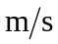for 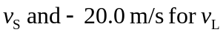 gives 267 Hz.

